2.27: a) speeding up:

slowing down:

b)
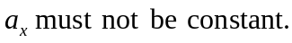

c)
